A Voice Before Launch
Description | Before Halo 2 launched in 2004, its promotional campaign had players answering real payphones to unlock pieces of an audio story. I'm trying to find one of those original clips: a junior officer suspects a ship's records were deliberately erased, while his superior denies a cover-up. When he suggests asking the captain to confirm the story, his superior says she is dead. I never found out what the filename was for the full recording. Could you get the name?
Files | Text-only OSINT challenge; publish the player brief. No downloadable starter or container. Submit RCC{filename.wav}. Solving this challenge unlocks The Axon That Moved.
Hint(s) | 1. Halo 2's launch had a story that crossed from the web into the telephone network.  2. Look for the original, individually named audio fragments of I Love Bees. Full chapters can join several different files.  3. The contemporary guide's Recipe 3 Take 3 section contains this conversation. Check the matching individual link on an archived recipe3.html page.
Walkthrough | 1. Identify I Love Bees, the 2004 Halo 2 campaign. Search I Love Bees erased records captain dead to find transcripts of its telephone recordings, including the Wonderweasels guide.  2. Open Recipe 3 — Take 3 and click the § beside the section to expand its transcript. The passage labelled standish.wav contains the missing records, the superior's denials, and the captain's death. The following harmony.wav begins with the bus-accident discussion; it is a separate recording.  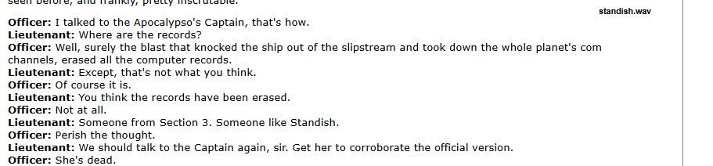  3. Open the original Recipe 3 page's September 23, 2004 capture. Find standish, then copy its link address or view the page source. The original destination is http://transmit.ilovebees.com/outbound/standish.wav, confirming the filename standish.wav.
Flag | RCC{standish.wav}

